Budgeting and controlling
Midterm project
Ali abdelshafy
Please answer all 4 questions.
Question 1
MIDTERM EXAM
SuperLock manufactures and sells three types of high security door knobs, Brass, Chrome, and White. Differentiating the three products on the basis of price is important to SuperLock as Brass, Chrome and White knobs appeal to different consumer markets. The company uses a traditional cost- ing system that allocates overhead costs (i.e. setup and inspection costs) based on direct labour hours. The following data apply:
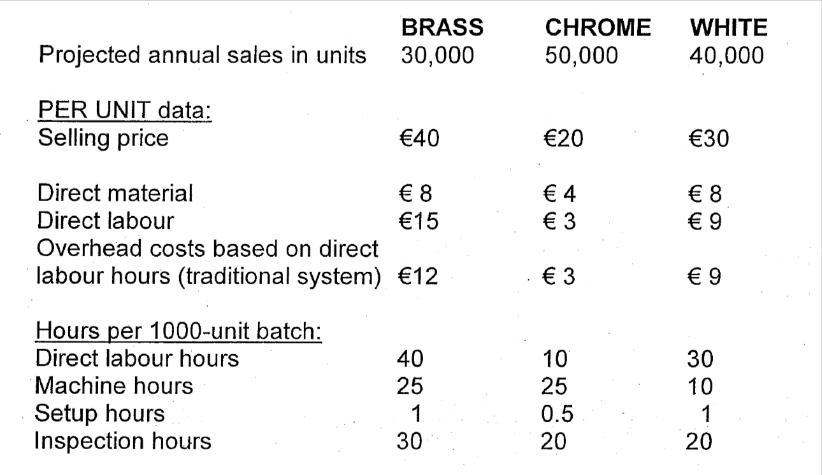
Total activity levels and setup and inspection costs for the year are estimated as follows:
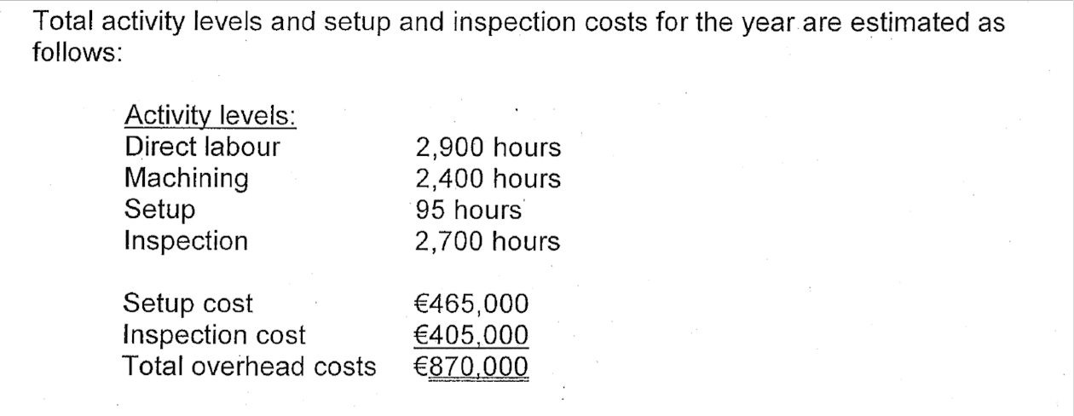
Required
- a) Calculate the per unit profit level for each knob type that would be reported by the traditional costing system:
- b) Calculate the per unit profit level for each knob type that would be reported by an activity based costing system.
- c) Do both systems support corporate strategy? Discuss in the light of your results in (a) and (b) above.

